Day 2 – Problem Validation & User Research
Project
ProcurAgent – AI-Powered Automotive Procurement & Supplier Risk Management System
Day 2 Summary
Day 2 focused on understanding users and stakeholders, validating their problems, documenting user needs, and representing the current and proposed business workflows.
Concepts Learned
1. Empathy
Understanding the user's needs, problems, expectations, and experiences from the user's perspective.
2. Stakeholder
A person or group that uses, interacts with, supports, influences, or is affected by the system.
3. User Research
Collecting information about users to understand their goals, problems, workflows, and expectations.
4. Interview
A structured conversation with a stakeholder or user to collect information about their real problems and working process.
5. Persona
A realistic representation of a target user based on user research.
Example:
Procurement Manager – wants reliable supplier selection, early risk visibility, and faster procurement decisions.
6. User Story
A requirement written from the user's point of view.
Format:
As a [user], I want [action], so that [benefit].
Example:
As a Procurement Manager, I want to compare suppliers so that I can select a reliable supplier.
7. Acceptance Criteria
Conditions that must be satisfied for a user story or feature to be considered complete and correct.
8. Business Process
A sequence of activities followed by a business to achieve a particular goal.
9. AS-IS Process
The way a business process works currently.
Example:
Procurement Need → Manual Data Collection → Supplier Comparison → Decision
10. TO-BE Process
The proposed way the process should work after the new solution is implemented.
Example:
Procurement Need → ProcurAgent Analysis → Supplier Comparison → Risk Assessment → Recommendation → Human Approval
11. Use Case
A specific goal or interaction between a user and the system.
Example:
Procurement Manager → Analyze Supplier Risk
12. Actor
A person or external system that interacts with the system.
Examples:
- Procurement Manager
- Supplier
- ERP / External System
13. Activity Diagram
A diagram that represents the step-by-step flow of activities in a process.
14. User Journey
The sequence of experiences and interactions a user goes through while achieving a goal.
15. Data Cleaning
Preparing raw data by identifying and correcting issues such as missing values, duplicate records, incorrect formats, and inconsistent data.
16. Bagging
Bagging (Bootstrap Aggregating) is an ML technique that trains multiple models on different samples of data and combines their predictions to improve stability and reduce overfitting.
17. Ratio
A comparison between two quantities.
18. Proportion
A relationship showing that two ratios are equal.

Diagram / Picture Space
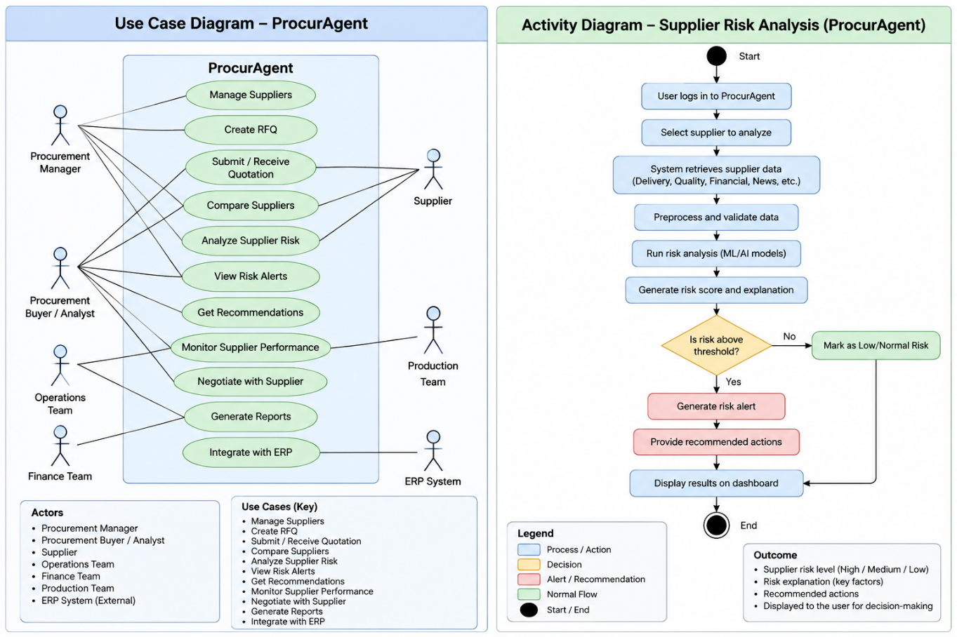
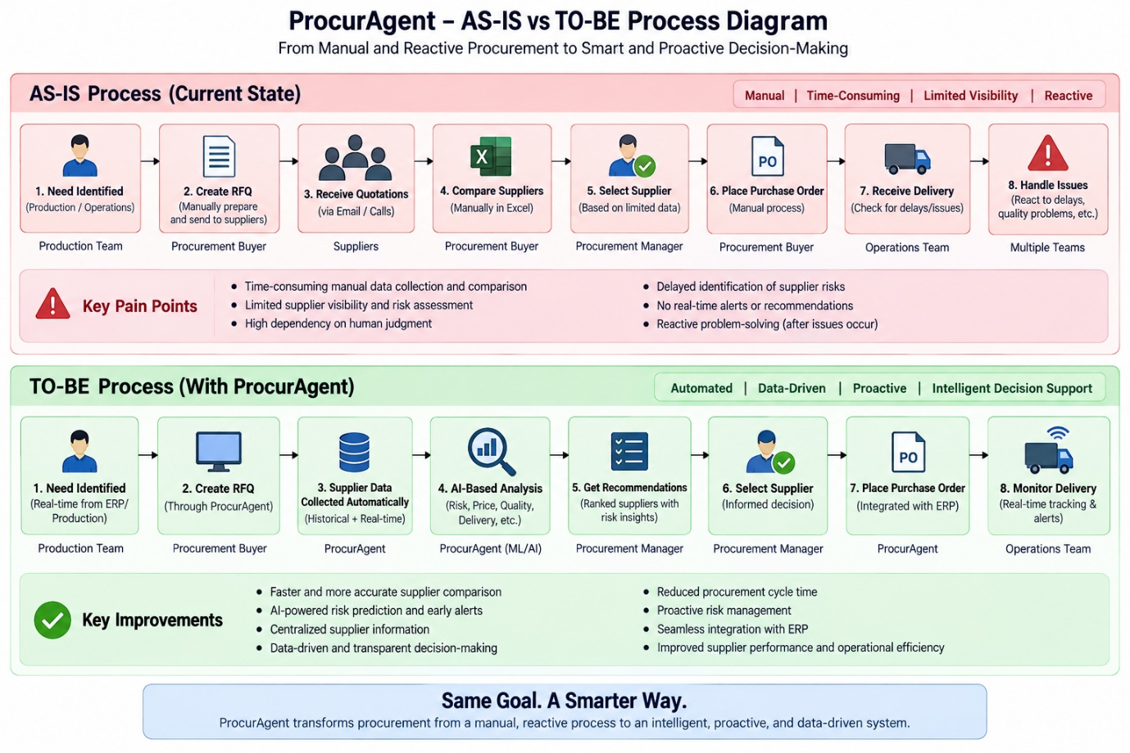

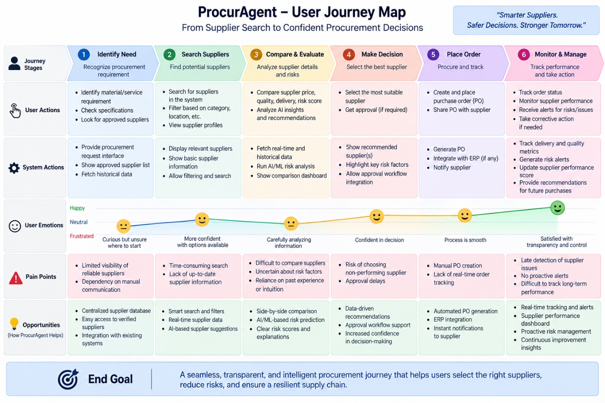
Day 2 Learning Outcome
By the end of Day 2, the concepts of empathy, user research, stakeholders, personas, user stories, acceptance criteria, business processes, use cases, activity flows, user journeys, data cleaning, and bagging were understood.
Key Takeaway
Empathy → User Research → Stakeholders → Personas → User Stories → Acceptance Criteria → AS-IS → TO-BE → Use Case → Activity Flow → User Journey → Data Preparation → ML

